**Master Functional Document**

|  |  |
| --- | --- |
| **Application** | NGERP – Centra |
| **Service Bundle** | Master Management |
| **Service Request** | Discount Schema |

**Description:**

In Compiere **(NGERP – Centra), t**he Discount Schema defines how trade discounts are calculated from the list price, including rules for price adjustments, surcharges, and margin settings. It helps set final prices after applying discount percentages, making it essential for managing product pricing.

**Workflow Process:**

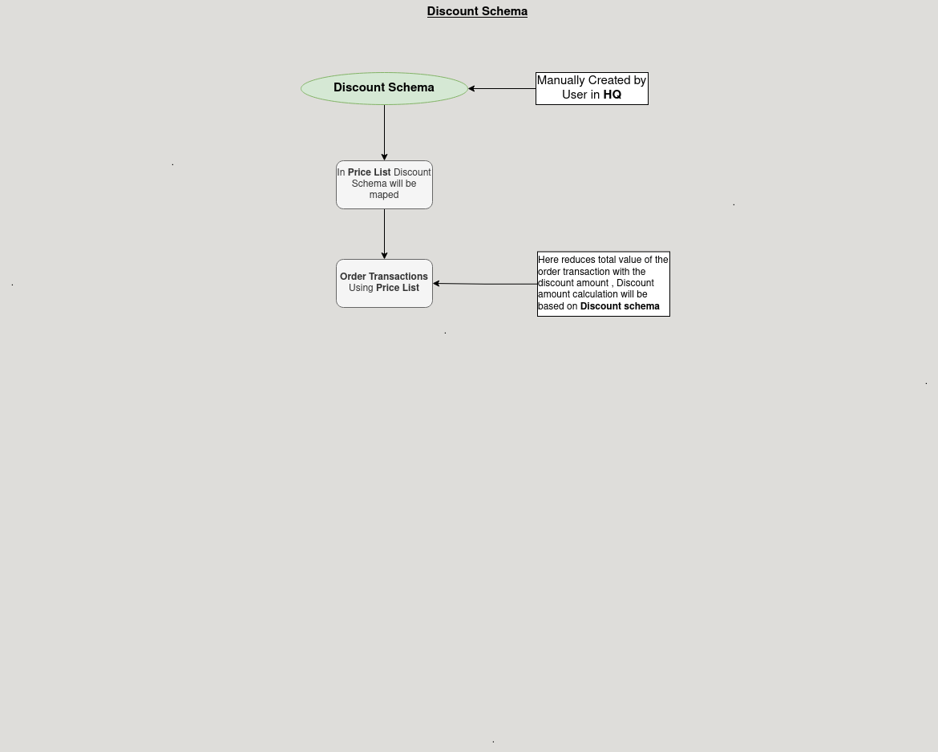

**Business Rules:**

* Discount Schema is visible in both HQ and ROW.
* Data is shared across branches, but the schema can only be created at the HQ level.
* Discount Schema calculates final prices after applying trade discounts to the list price.
* Price Lists are based on List Price, Standard Price, or Limit Price.
* Discounts can depend on quantity or business partner.